Akhilanand Sirra (002197798)

**Program Structures & Algorithms**

**Fall 2021**

**Assignment No. 1**

* **Task**

Imagine a drunken man who, starting out leaning against a lamp post in the middle of an open space, takes a series of steps of the same length: 1 meter. The direction of these steps is randomly chosen from North, South, East or West. **After n steps, how far (*d*), generally speaking, is the man from the lamp post?** Note that *d* is the Euclidean distance of the man from the lamp-post.

It turns out that there is a relationship between *d*and *n* which is typically applicable to many different types of stochastic (randomized) experiments. Your task is to implement the code for the experiment and, most importantly**, to deduce the relationship.**

* **Relationship Conclusion:**

$$d≈\sqrt{n}$$

d = Euclidean distance of the drunken man from the lamp-post

n = number of steps taken

* **Evidence to support the conclusion:**

1. **Output  
   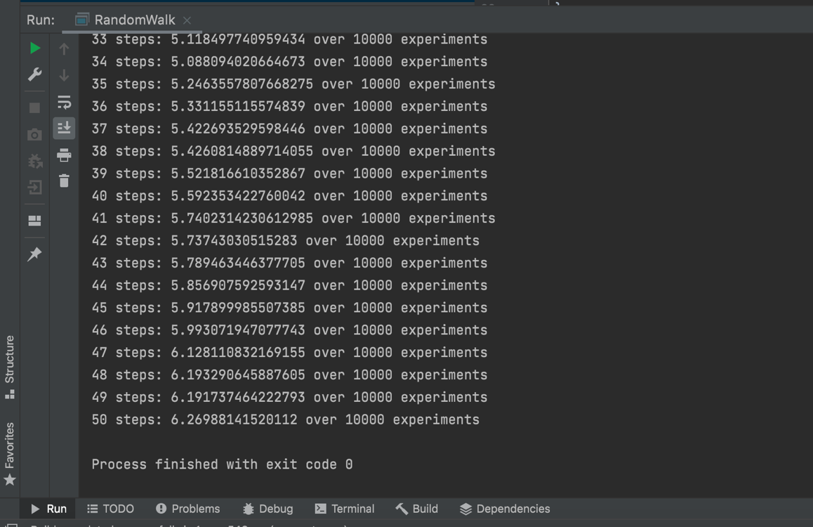**
2. **Graphical Representation (Observations from experiments should be tabulated and analyzed by plotting graphs (usually in excel) to arrive on the relationship conclusion)**

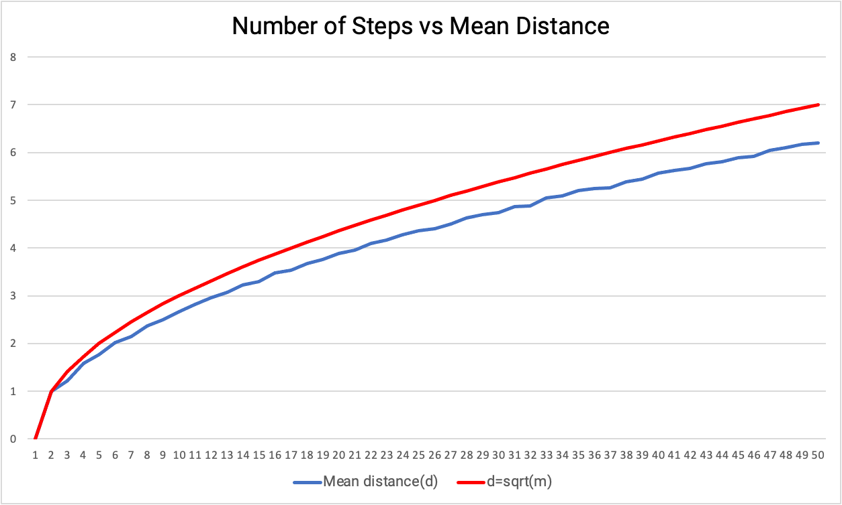

The graph plotted between the number of steps and mean distance shows that the drunk man moves about the square root of the number of steps(n).

|  |  |  |  |
| --- | --- | --- | --- |
| **Number of Steps(m)** | **Mean distance(d)** | **d=sqrt(m)** | **Experiments** |
| 0 | 0 | 0 | 10000 |
| 1 | 1 | 1 | 10000 |
| 2 | 1.214466579 | 1.41421356 | 10000 |
| 3 | 1.588547783 | 1.73205081 | 10000 |
| 4 | 1.765329896 | 2 | 10000 |
| 5 | 2.018707574 | 2.23606798 | 10000 |
| 6 | 2.150847117 | 2.44948974 | 10000 |
| 7 | 2.365256444 | 2.64575131 | 10000 |
| 8 | 2.50244357 | 2.82842712 | 10000 |
| 9 | 2.668036033 | 3 | 10000 |
| 10 | 2.821153914 | 3.16227766 | 10000 |
| 11 | 2.965561226 | 3.31662479 | 10000 |
| 12 | 3.070081856 | 3.46410162 | 10000 |
| 13 | 3.220345127 | 3.60555128 | 10000 |
| 14 | 3.299650957 | 3.74165739 | 10000 |
| 15 | 3.483934963 | 3.87298335 | 10000 |
| 16 | 3.535005625 | 4 | 10000 |
| 17 | 3.669182814 | 4.12310563 | 10000 |
| 18 | 3.761075754 | 4.24264069 | 10000 |
| 19 | 3.88006566 | 4.35889894 | 10000 |
| 20 | 3.949901195 | 4.47213595 | 10000 |
| 21 | 4.097012746 | 4.58257569 | 10000 |
| 22 | 4.163656973 | 4.69041576 | 10000 |
| 23 | 4.280965263 | 4.79583152 | 10000 |
| 24 | 4.358048308 | 4.89897949 | 10000 |
| 25 | 4.399514703 | 5 | 10000 |
| 26 | 4.501728789 | 5.09901951 | 10000 |
| 27 | 4.632587885 | 5.19615242 | 10000 |
| 28 | 4.700251922 | 5.29150262 | 10000 |
| 29 | 4.740762487 | 5.38516481 | 10000 |
| 30 | 4.868995218 | 5.47722558 | 10000 |
| 31 | 4.887339036 | 5.56776436 | 10000 |
| 32 | 5.044883799 | 5.65685425 | 10000 |
| 33 | 5.086772541 | 5.74456265 | 10000 |
| 34 | 5.2044642 | 5.83095189 | 10000 |
| 35 | 5.249118169 | 5.91607978 | 10000 |
| 36 | 5.264251121 | 6 | 10000 |
| 37 | 5.383647793 | 6.08276253 | 10000 |
| 38 | 5.446687771 | 6.164414 | 10000 |
| 39 | 5.570607359 | 6.244998 | 10000 |
| 40 | 5.626200503 | 6.32455532 | 10000 |
| 41 | 5.663284822 | 6.40312424 | 10000 |
| 42 | 5.765231556 | 6.4807407 | 10000 |
| 43 | 5.806813422 | 6.55743852 | 10000 |
| 44 | 5.887588862 | 6.63324958 | 10000 |
| 45 | 5.921694147 | 6.70820393 | 10000 |
| 46 | 6.043563305 | 6.78232998 | 10000 |
| 47 | 6.102012136 | 6.8556546 | 10000 |
| 48 | 6.165892852 | 6.92820323 | 10000 |
| 49 | 6.193714445 | 7 | 10000 |
| 50 | 6.256945294 | 7.07106781 | 10000 |

For larger values of n, although not equal, the mean distance of the drunken man is pretty close to the square root of the number of steps(n).

As the distance between the lamp-post and drunken man is calculated using the Pythagorean theorem, which is nothing but the square root of distances from the origin. Hence, the relationship between *d*and *n* is almost identical to the sqrt(n).

* **Unit tests result:**

